Another Way Pregnancy Center
presents our
2014 Annual Fundraising Banquet

Thursday, October 9th
Glen Oaks Golf and Conference Center
30500 W. 13 Mile Rd., Farmington Hills, MI 48334
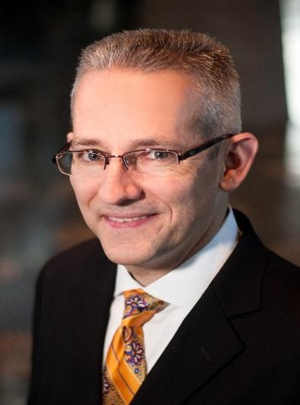

Speaker: David Bereit Emcee: Jason Hanson
David Bereit became an outspoken pro-life advocate after Planned Parenthood announced plans to build an abortion clinic in his Texas town in 1998. He helped to start and build a local grassroots coalition that rallied 60 churches and thousands of people together and dramatically reduced abortions in the region. Planned Parenthood recognized the effectiveness of David's efforts when it labeled his town "the most anti-choice place in the nation." David led the first-ever 40 Days for Life campaign in College Station, Texas.
Jason Hanson may be best known for his 21-year career playing for the Detroit Lions, but the real “field goal” of his life is serving the Lord with excellence.
Doors Open: 6:30 p.m.
Program & Dinner: 6:45 – 9:00 p.m.
Adults Only, Please!
An opportunity to make a financial contribution will be extended to fund the ministry of Another Way Pregnancy Center.

Banquet Guests may also join us for DESSERT FIRST, a pre-banquet tour of Another Way Pregnancy Center!
31700 W. 12 Mile Rd. – just west of Orchard Lake Rd.
Tours begin at 5:00 – line closes at 6:05 p.m.
Have your photo taken with Jason Hanson! Photos will be autographed and distributed following the banquet.

For reservations or more information, please contact AWPC:
(248) 471-5858 or AWPCfriends.com/events

